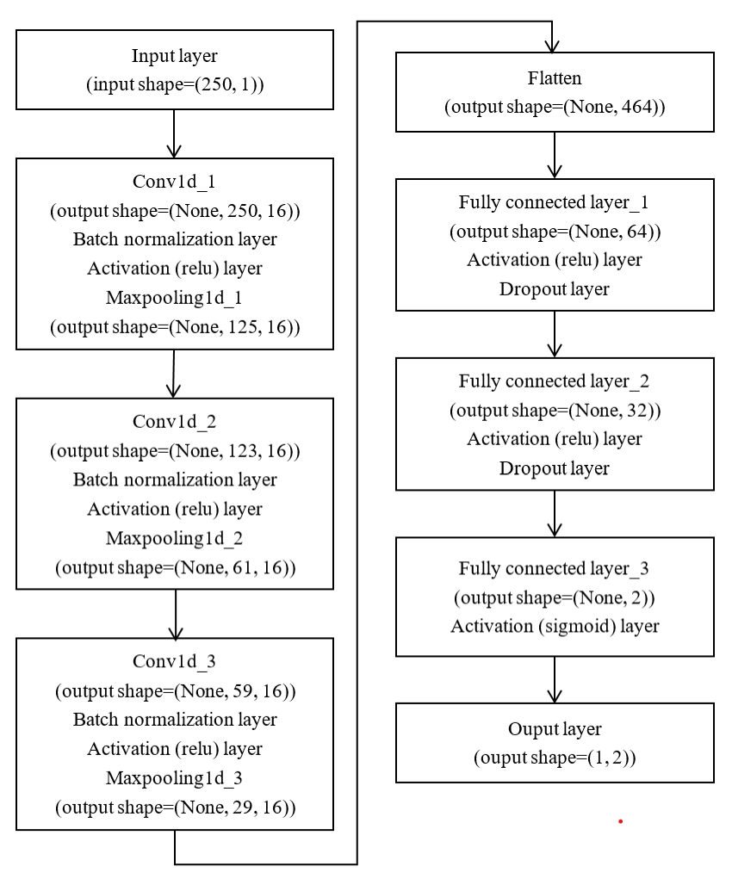

Fig. 1 The DCNN architecture

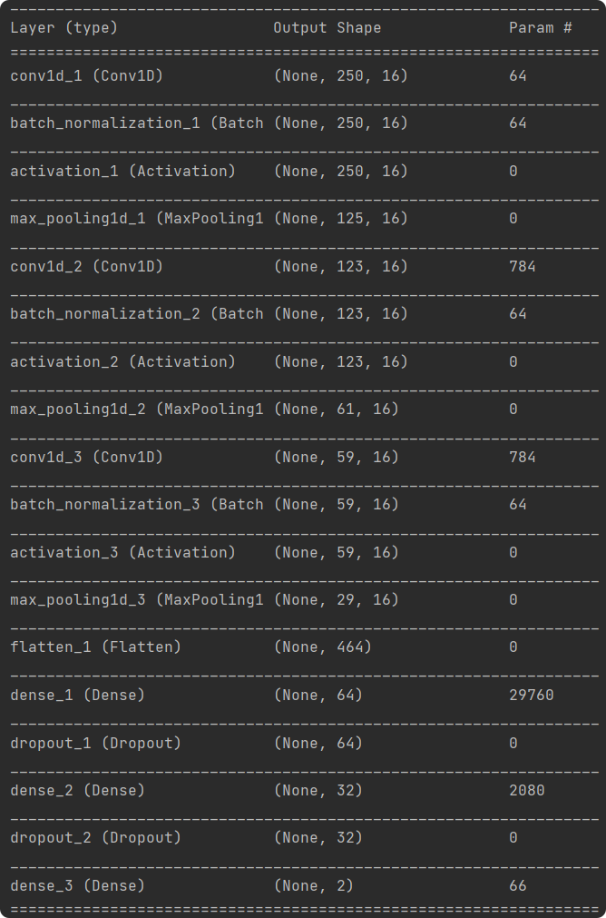

Fig. 2 Running of the DCNN architecture